



Admissions Statement



Old Park School Admissions Statement

Old Park is an all age school catering for pupils with severe and profound learning difficulties. Admission to Old Park School is through a recommendation from an Education Health and Care Plan. To be considered for a place, a pupil will have, or be in the process of receiving, an Education Health and Care Plan. The plan will identify and detail the pupils needs and will include severe learning or profound and multiple learning difficulties.

Pre-Visits

Before contacting school, families are required to speak to the Dudley SEND team. They will ensure that families are signposted to the most appropriate provision within the borough. When it is deemed that Old Park School is a suitable setting, then families are welcome to contact school to arrange a pre-visit. Old Park offers group pre-visits on identified dates throughout the autumn and spring term. We do not routinely offer pre-visits during the summer term, except in exceptional circumstances. Families are also actively encouraged to visit our school website.

Representation, Referral and Consultation

The Local Authority is responsible for the pupils Education Health and Care Plan (EHCP) and retains the responsibility for deciding whether to name Old Park School in the plan, based on the individual needs of the child.

Referrals and representations can be made from several sources including mainstream or other special schools, pre-school assessment units and specialist nurseries. Parents and carers may make representations for a placement at Old Park School.

The Local Authority is required to consult with Old Park School before naming it in the child’s EHCP. The Headteacher has 15 calendar days in which to respond to the formal consultation.

A request for a place at Old Park School must be agreed by the school and the LA SEND panel.

Old Park School will not agree to admission where it is felt that –

* the school is unsuitable for the student’s age, aptitude or special educational needs
* attendance at the school would be incompatible with the provision of efficient education for others
* attendance at the school would be incompatible with the efficient use of the school’s resources

Multi-Agency Contact

The Headteacher may direct a member of the Senior Leadership Team and/or the Family Support Lead, to carry out an informal observation of the child in their current setting/home. They may also gain further information by speaking to the current teacher or lead. This may include information on developmental levels, behavior, or wider holistic needs.

Admission into School

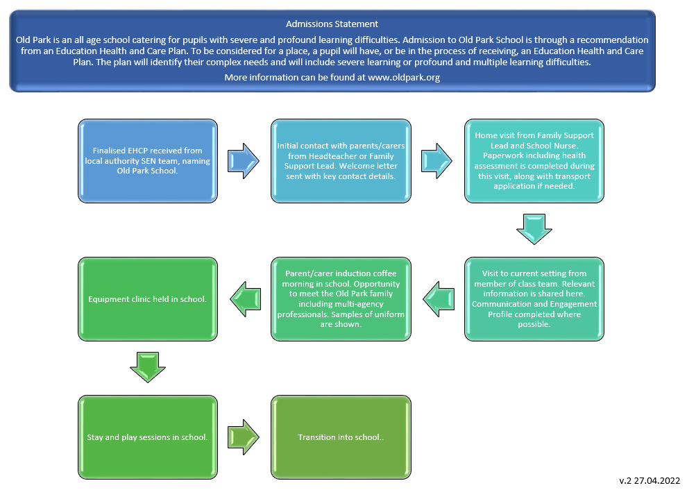

Families may contact Dudley LA SEN Team using the following details

The Special Educational Needs & Disabilities (SEND) Assessment Team

Ladies Walk Centre,

Ladies Walk Sedgley,

Dudley,

West Midlands.

DY3 3UA

01384 814360

[senteam@dudley.gov.uk](mailto:senteam@dudley.gov.uk)

<https://www.dudley.gov.uk/resident/localoffer>

*Old Park School understands the importance of safely obtaining and storing personal data and is committed to following all aspects of UK General Data Protection Regulations (GDPR).  All information gathered and held in respect of this policy will be protected in line with current General Data Protection Regulations and the Data Retention Policy*.

Reviewed September 2024

B Jones